WINDOW FUNCTION
QUERY 1 : Rank products by total revenue
SELECT
Product,
SUM(Revenue) AS Total_Revenue,
RANK() OVER (ORDER BY SUM(Revenue) DESC) AS Revenue_Rank
FROM sales
GROUP BY Product;

OUTPUT
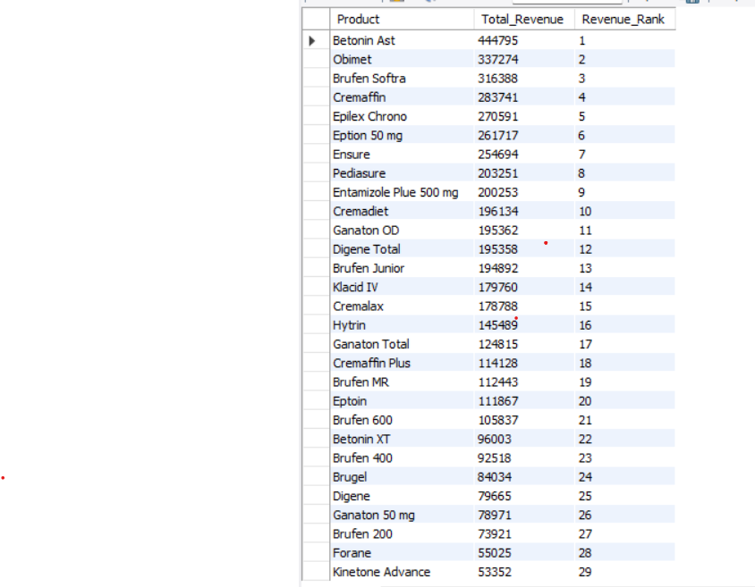

QUERY 2 : Rank products within each region
SELECT
Region,
Product,
SUM(Revenue) AS Total_Revenue,
RANK() OVER (
PARTITION BY Region
ORDER BY SUM(Revenue) DESC
) AS Product_Rank
FROM sales
GROUP BY Region, Product
LIMIT 10;

OUTPUT

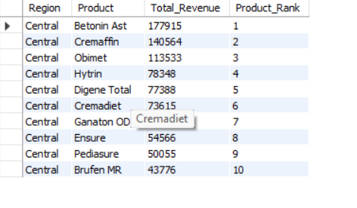

QUERY 3 : Running total of revenue by date
SELECT
Date,
SUM(Revenue) AS Daily_Revenue,
SUM(SUM(Revenue)) OVER (
ORDER BY Date
) AS Running_Revenue
FROM sales
GROUP BY Date
ORDER BY Date
LIMIT 10;

OUTPUT
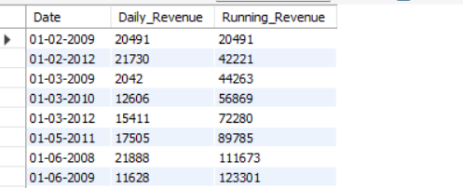

QUERY 4 : Compare revenue with regional average

SELECT
Date,
Region,
Product,
Revenue,
AVG(Revenue) OVER (
PARTITION BY Region
) AS Region_Avg_Revenue,
Revenue -
AVG(Revenue) OVER (
PARTITION BY Region
) AS Difference
FROM sales
LIMIT 10;

OUTPUT
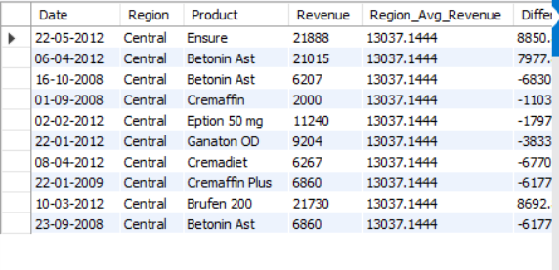

QUERY 5 : Previous sale comparison using LAG
SELECT
Date,
Product,
Revenue,
LAG(Revenue, 1) OVER (
ORDER BY Date
) AS Previous_Revenue,
Revenue -
LAG(Revenue, 1) OVER (
ORDER BY Date
) AS Revenue_Change
FROM sales
limit 10;

OUTPUT
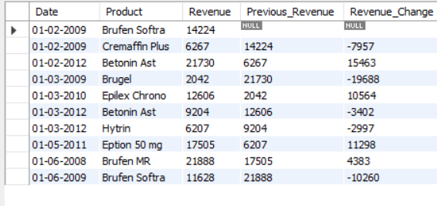

SUBQUERIES
QUERY 6 : Products with revenue above average
SELECT
Product,
SUM(Revenue) AS Total_Revenue
FROM sales
GROUP BY Product
HAVING SUM(Revenue) >
(
SELECT AVG(Revenue)
FROM sales
)
LIMIT 10;

OUTPUT

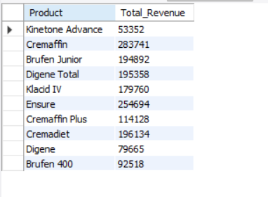

QUERY 7 : Find highest revenue transaction

SELECT *
FROM sales
WHERE Revenue =
(
SELECT MAX(Revenue)
FROM sales
)
LIMIT 10;

OUTPUT



QUERY 8 : Regions whose revenue is above company average

SELECT
Region,
SUM(Revenue) AS Total_Revenue
FROM sales
GROUP BY Region
HAVING SUM(Revenue) >
(
SELECT AVG(Region_Total)
FROM
(
SELECT
SUM(Revenue) AS Region_Total
FROM sales
GROUP BY Region
) AS Region_Sales
);

OUTPUT

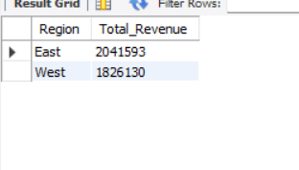

CTE (COMMON TABLE EXPRESSIONS)

QUERY 9 : Top 5 products by revenue using CTE

WITH Product_Sales AS
(
SELECT
Product,
SUM(Revenue) AS Total_Revenue
FROM sales
GROUP BY Product
)

SELECT *
FROM Product_Sales
ORDER BY Total_Revenue DESC
LIMIT 5;

OUTPUT

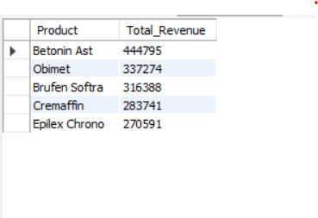

QUERY 10 : Region-wise revenue contribution

WITH Region_Revenue AS
(
SELECT
Region,
SUM(Revenue) AS Total_Revenue
FROM sales
GROUP BY Region
)

SELECT
Region,
Total_Revenue,
ROUND(
(Total_Revenue * 100.0) /
(SELECT SUM(Total_Revenue) FROM Region_Revenue),
2
) AS Revenue_Percentage
FROM Region_Revenue;

OUTPUT

